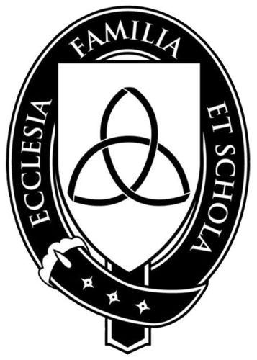

Veritas Academy
1st Grade Reading List

2013-2014

History Course - Seven Continents and Seven Seas: This course is an elementary introduction to world geography. It will study each of the seven continents, learning about its topography, flora, fauna, people, nations, cities, customs and traditions.

Veritas has varying numbers of each book available for borrowing (one to two books at a time). Check with the teacher for availability once the term begins. It is the responsibility of parents to obtain the books, from Veritas if available, or from local bookstores, public libraries or Internet sites. Here are some sources for ordering books. The book codes are given for those who wish to order through Sonlight Curriculum.
- Sonlight Curriculum: www.sonlight.com.
- www.amazon.com.
- Barnes and Noble Online: www.bn.com
- Used book stores or Internet sites (e.g. www.abebooks.com)

Read-Alouds (read by parent to student)

Favorite Poems of Childhood by Philip Smith SL #1A20
*The Librarian Who Measured the Earth by Kathryn Lasky VP #346-010
*Maps and Globes by Jack Knowton SL #2H01
Little House on the Prairie by Laura Ingalls Wilder (Amazon.com)
*The Year of Miss Agnes by Kirkpatrick Hill SL #1A08
*Simon Bolivar by Frank DeVarona SL #4H41
The Aesop for Children Illustrated by Milo Winter SL #2A20
White Stallion of Lipizza by Marguerite Henry SL #2A23
*The Little Riders by Margaretha Shemin SL #2A16
*Marco Polo by Charles Graves SL #2X37
*Little Pear by Eleanor Lattimore SL #2A02
Mountain Born by Elizabeth Yates SL #1A17
*A Question of Yams by Gloria Repp SL #2X11
*Twenty One Balloons by William Pene DuBois SL #2A04
*Mr. Popper’s Penguins by Richard Atwater SL #1A15
Betsy, Tacy and Tib by Maude Lovelace (Amazon.com)
The Light at Tern Rock by Julia Sauer (Amazon.com)
The Boxcar Children by Gertrude Warner (Amazon.com)
Gooney Bird Green by Lois Lowry SL #1A05 (alternate)
*Star of Light by Patricia St. John SL #5R26 (alternate/parental editing)

*These books correspond to Seven Continents and Seven Seas specifically.

Readers (read by the students themselves)

The Best Trick by Rebecca Lewis #1R13
Green Eggs and Ham by Dr. Seuss #1R10
Little Bear by Else Minarik #1R03
Cat in the Hat by Dr. Seuss #1R06
Stop That Ball by Mike McClintock (Amazon.com)
A Big Ball of String by Marion Holland #1R12
The Bravest Dog Ever by Natalie Standiford #1R14
One Fish, Two Fish by Dr. Seuss #1R04
My Little Boy by Joan Phillips (Amazon.com)

Literature Units (provided by Veritas Academy and studied in class)

McGuffey’s Eclectic Pictorial Primer Madeline by Ludwig Bemelmans
The Little Engine that Could by Watty Piper
Caps for Sale by Esphyr Slobodkina
Corduroy by Don Freeman
Curious George by H. A. Rey
Blueberries for Sal by Robert McCloskey
Henry and Mudge by Cynthia Rylant
The Magic Fish by Freya Littledale and Winslow Pels
Stone Soup by Marcia Brown
A New Coat for Anna by Harriet Ziefert and Anita Lobel
Bread and Jam for Frances by Russell Hoban
Frog and Toad Together by Arnold Lobel
Mike Mulligan and More by Virginia Lee Burton
Tales of Peter Rabbit by Beatrix Potter

