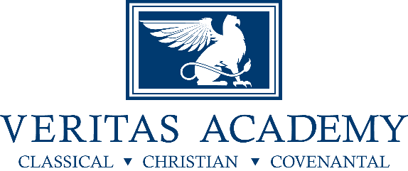
Supply List for ALL PE Classes 2018-19
- Veritas PE Shirt available for purchase in the school office
- Veritas PE athletic shorts available for purchase in the school office
- Athletic shoes
- Water bottle

